Calvary United Methodist Church
Sunday, February 21, 2021; 10:15 am
Welcome and Announcements
Prelude Dee Freeman
Call To Worship
Come! Let’s worship God, who makes and keeps covenant.
Come! See the sign of God’s promise in rainbow and rhythm.
Come! Let’s worship Almighty God! Hallelujah!

Invocation of the Spirit
Second Testament Lesson 1 Peter 3:18-22
“For Christ also suffered for sins once for all, the righteous for the unrighteous, in order to bring you to God. He was put to death in the flesh, but made alive in the spirit, in which also he went and made a proclamation to the spirits in prison, who in former times did not obey, when God waited patiently in the days of Noah, during the building of the ark, in which a few, that is, eight persons, were saved through water. And baptism, which this prefigured, now saves you—not as a removal of dirt from the body, but as an appeal to God for a good conscience, through the resurrection of Jesus Christ, who has gone into heaven and is at the right hand of God, with angels, authorities, and powers made subject to him.” (NRSV)
Declaration of Praises
Sharing of Prayer Concerns
Prayer Time
Lenten Reading
Leader: Today we place the crown of thorns upon the cross. With a crown of thorns we mocked and marred the one who proclaimed a Kingdom we did not want. But today we also remember a redemption that came to us through suffering.
People: Lord Jesus, with a crown of thorns we mocked the Kingdom you proclaimed. With a crown of thorns we rejected you as our King. Help us say “No” to our private notions of how the Kingdom of God should look. Help us say “Yes” to the cross.
Leader: Throughout the centuries we have ascribed greatness to those who bring quick resolutions to our political conflicts. We want immediate results with little cost.
People: Lord Jesus, we confess we are often disappointed in the Kingdom you reveal. Your Kingdom reflects your patience with creation. Your Kingdom requires our participation. Help us say “No” to our craving for ease and luxury. Help us say “Yes” to the cross.
Leader: Our world honors kings who enforce peace by destroying their enemies. The King we crowned with thorns established peace by dying for his enemies---the righteous for the unrighteous, to reconcile us to God.
People: Lord Jesus, we still look for leaders to bring peace through power. To the mighty, the strong, and the beautiful we grant our places of honor. Help us say “No” to our dread of weakness. Help us say “Yes” to the cross.
Leader: Let us pray together…
All: Almighty God, we want kingdoms with great power. Your Son came in weakness. We want deliverance through conquest. Your Son brought deliverance through suffering. We want freedom from temptation. Your Son participates in our struggles. Free us from our selves; deliver us from our evil; conform us to the image of your Son. Amen.

Scripture Lesson Galatians 5:22-26
“But the Holy Spirit produces this kind of fruit in our lives: love, joy, peace, patience, kindness, goodness, faithfulness, gentleness, and self-control. There is no law against these things! Those who belong to Christ Jesus have nailed the passions and desires of their sinful nature to his cross and crucified them there. Since we are living by the Spirit, let us follow the Spirit’s leading in every part of our lives. Let us not become conceited, or provoke one another, or be jealous of one another.” (NLT)
Sermon Rev. Matthew Williams
Shalom To You: God Brings Peace
Closing Hymn Lift High The Cross
Benediction
Postlude Dee Freeman

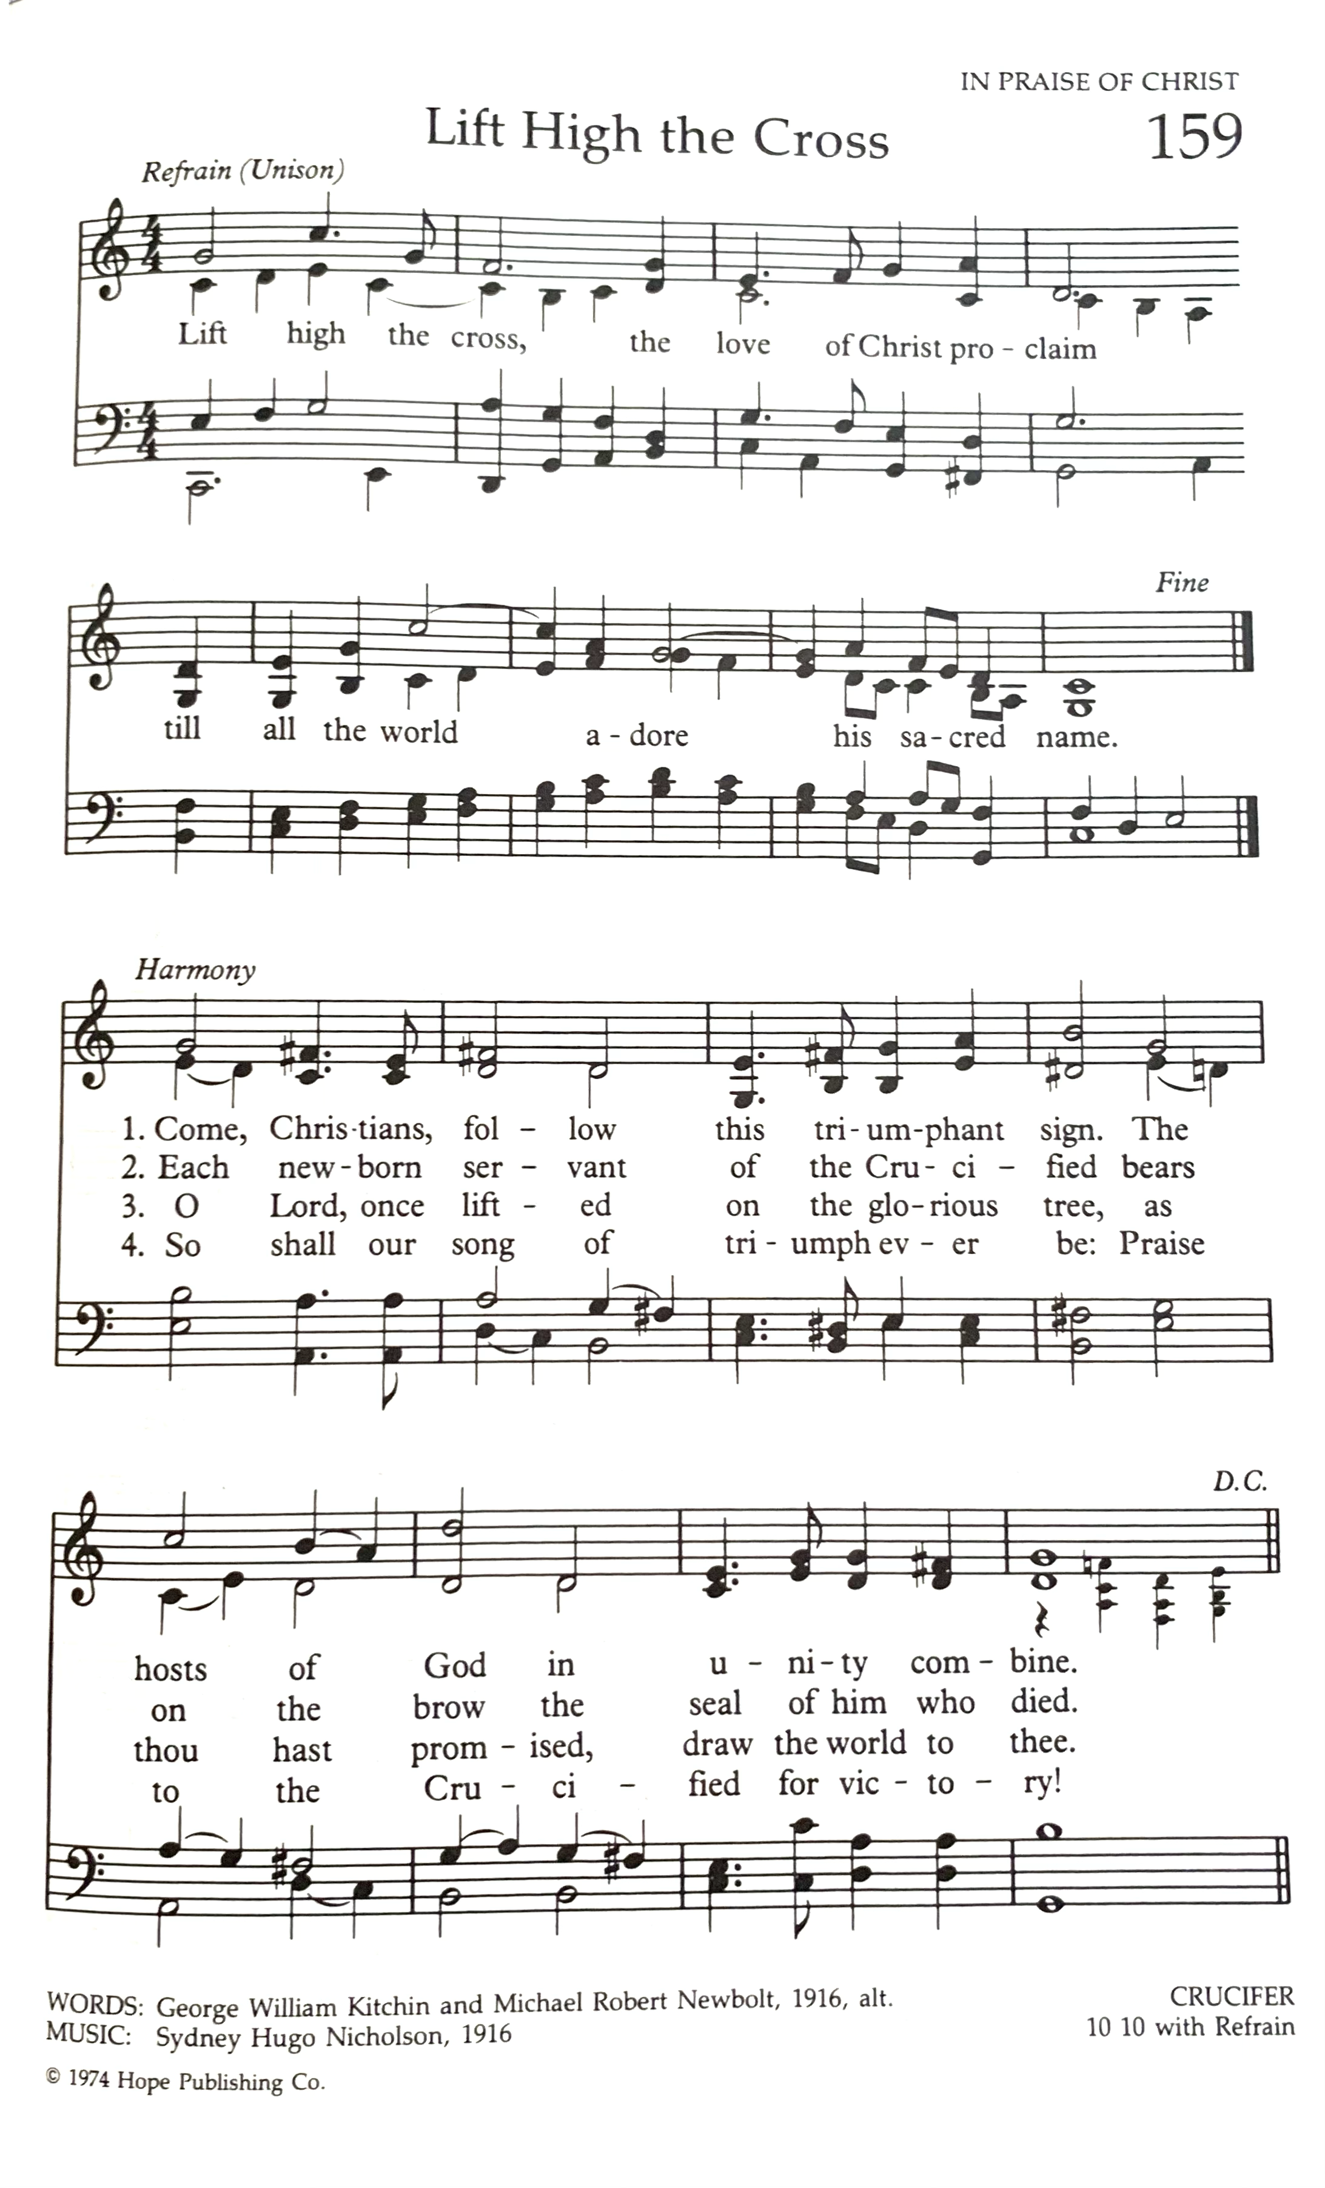

Valerie Bridgeman Davis, The Africana Worship Book for Year B, Discipleship
http://www.crivoice.org/lentliturgyYearB.html

